LAB FINAL vs B Ranken Technical College

NAME_____________________________ SCORE _________

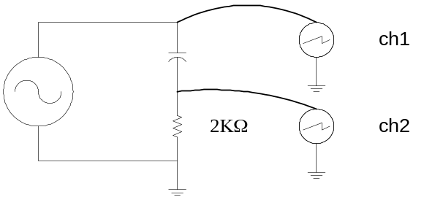

1. Channel 1 of the scope drawing
represents the phase of :

A. The current.
B. The voltage.

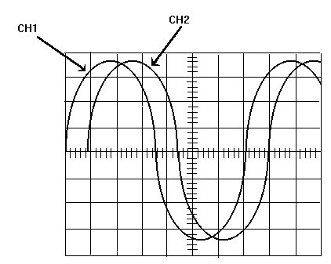2. Channel 2 of the scope drawing :
represents the phase of :

A. The current.
B. The voltage.

2ms time/cm

3. Solve

θ __________

Z __________

Freq __________

Xc __________

C __________

SHOW YOUR WORK

4. Band 1 - Orange Resistor Value = ________________
Band 2 - Yellow Tolerance in % = ________________
Band 3 - Red Tolerance in Ohms = _____________
Band 4 - Gold Maximum Resistor Value = _____________
Minimum Resistor Value = _____________

5. Band 1 - Gray Resistor Value = ________________
Band 2 - Blue Tolerance in % = ________________
Band 3 - Red Tolerance in Ohms = _____________
Band 4 - Silver Maximum Resistor Value = _____________
Minimum Resistor Value = _____________

6. Band 1 - Brown Resistor Value = ________________
Band 2 - Black Tolerance in % = ________________
Band 3 - Black Tolerance in Ohms = _____________
Band 4 - None Maximum Resistor Value = _____________
Minimum Resistor Value = _____________

7. Band 1 - Green Resistor Value = ________________
Band 2 - Violet Tolerance in % = ________________
Band 3 - Yellow Tolerance in Ohms = _____________
Band 4 - Gold Maximum Resistor Value = _____________
Minimum Resistor Value = _____________

8. Band 1 - Red Resistor Value = ________________
Band 2 - Yellow Tolerance in % = ________________
Band 3 –Red Tolerance in Ohms = _____________
Band 4 - Gold Maximum Resistor Value = _____________
Minimum Resistor Value = _____________

9. From the scope drawings determine the following values.
Time/cm 20us
Volt/cm 50mV
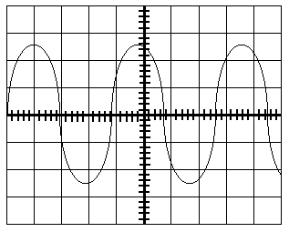

Time __________ frequency __________ Vpp __________ Vp __________ Vrms __________

10. From the scope drawings determine the following values.

Time/cm 2us
Volt/cm 100mV

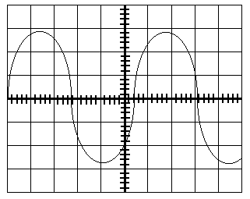

Time __________ frequency __________ Vpp __________ VP __________ Vrms __________

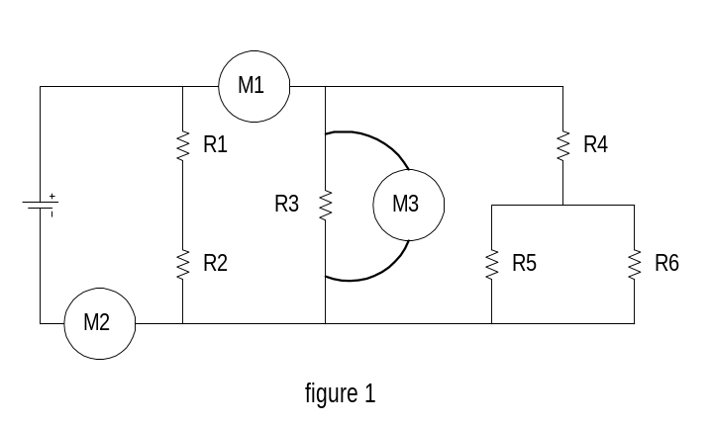
- Using the schematic in figure 1, what is meter 1 ________________________________________
- Using the schematic in figure 1, what is meter 2 measuring? ________________________________
- Using the schematic in figure 1, what is meter 3 measuring? _________________________________

14. From the drawing below answer the following questions.

a. Total current increase / decrease
b. What is the malfunction open / short
c. Define the malfunction _____________________________________________________

d. Knowing the type of malfunction, what will the voltage drops do across the components that do not have a change in resistance increase / decrease

e. Which component’s voltage does not follow the criteria in step d. R1 R2 R3
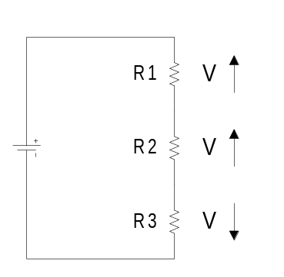

15. From the drawing below answer the following questions.

a. Total current increase / decrease

b. What is the malfunction open / short

c. Define the malfunction _____________________________________________________

d. Knowing the type of malfunction, what will the voltage drops do across the components that do not have a change in resistance increase / decrease

e. Which component’s voltage does not follow the criteria in step d. R1 R2 R3
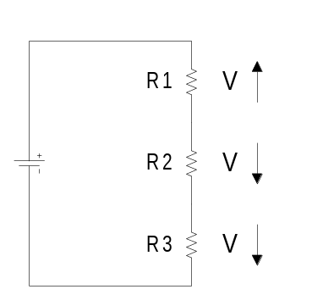

16. An open circuit can be described as:

- An increase in resistance that causes an increase in current.
- A decrease in resistance that causes an increase in current.
- A decrease in resistance that causes a decrease in current.
- An increase in resistance that causes a decrease in current.

17. A parallel circuit contains two branches. If a third resistor is added in parallel, what will voltage of branch 1 and branch 2 do?

- Go up
- Go down
- Stay the same.
- The current in branch 1 and branch 2 will exactly triple.

18. A parallel circuit contains two branches. If a third branch is added to the circuit, the totals circuit current will________.

- Go up
- Stay the same
- Go down
- None of the above are correct.

19. An short circuit can be described as:

- An increase in resistance that causes an increase in current.
B. A decrease in resistance that causes an increase in current.
C. A decrease in resistance that causes an increase in current.
D. A decrease in resistance that causes a decrease in current.

20. If an additional resistor is added in series, circuit current will:

- increase
- decrease
- no change

